School Motto: GATOR means we believe in…
Growing
Achievement
Together
Opportunities for all
Respect, Responsible, Resourceful
FYI: Bert Ambrose Goals
TO: Bert Ambrose Parents
- Social Responsibility: to improve our students’ ability to solve
problems in peaceful ways through critical thinking and self regulation
strategies requesting students to work on solving their own problems
first and know when to seek adult support.
- Literacy: work to maintain and improve reading skills in fluency and
comprehension, school wide.
- Critical Thinking: to improve the critical thinking skills of all our
Students using our own designed rubric to be measured at each reporting
period!

Research has shown these 3 skills are needed when applying for a job in the future!
More employers are looking for emplyees with academic, as well as good thinking and communication skills. In particular, employees who learn quickly, can solve problems, think creatively, gather research and analyze information meaningfully will be a valuable employee!

Each month our flyer/postcard will share strategies taught in class and ways to help your child learn skills to accomplish these goals!
-read independently or with an adult nightly!
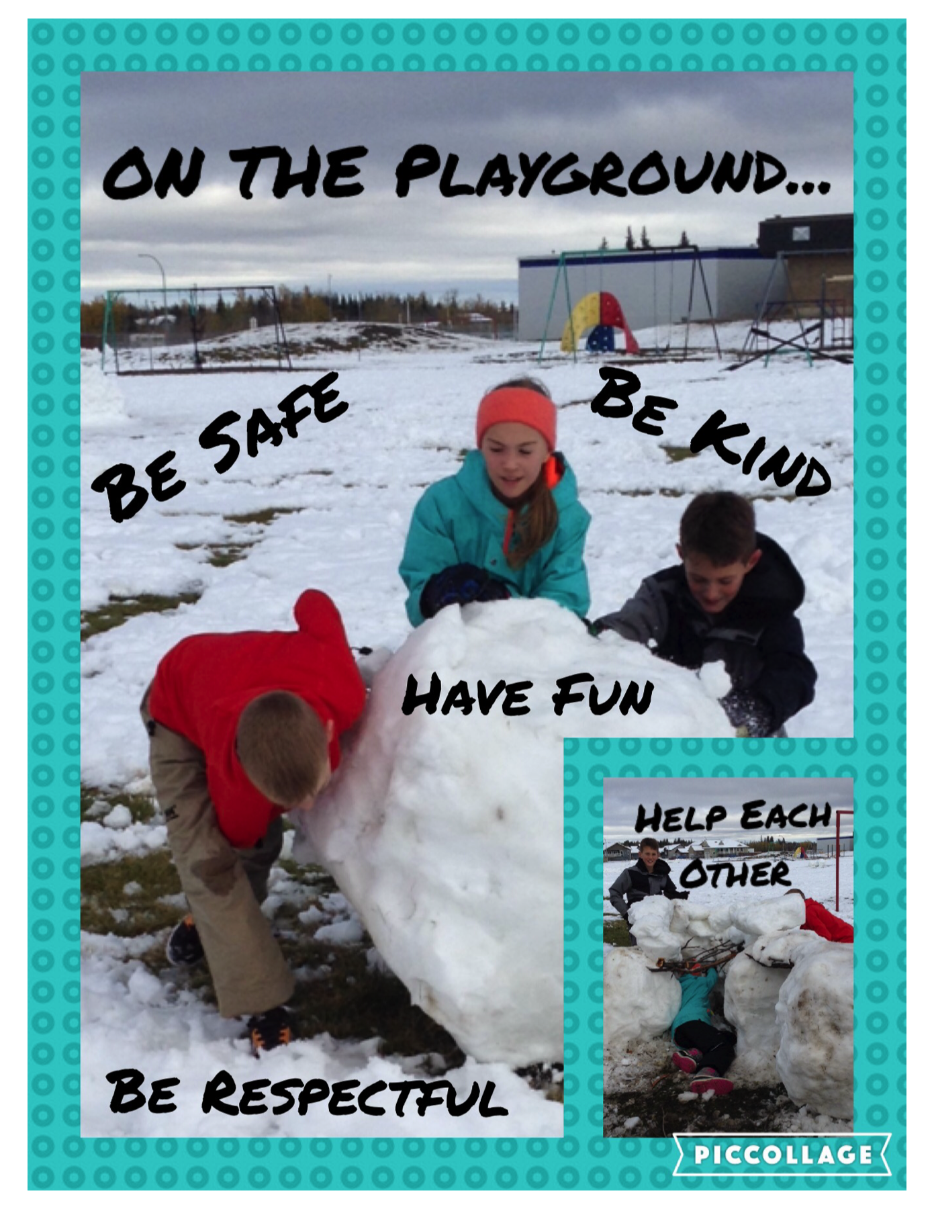
-sing a song created with Rik Leaf!
-use materials to create or build something fun!
-reminders to “respect personal space so everyone is safe”!
-practise deep breathing (anger or frustration takes oxygen away from the brain making thinking more difficult, deep breathing by milkshake breathing, smell the flower blow out the candle, close your eyes take a break or
make a figure 8 brings oxygen to the brain allowing children to achieve their full potential!)
FROM: Bert Ambrose Staff

“Striving together to achieve our potential for a better tomorrow.”

